1 What are coroutines and explain uses?

**Way to asynchronously execute tasks, used to execute tasks in the background away from the main thread**

2 What are suspend functions?

**A function that can be paused and resumed at a later time**

3 What are sealed classes

**Classes that inherit from it have to be in the same file as the sealed class**

4 enum vs sealed classes

**enum is a special class that represents a group of constants**

5 Explain Extension functions with example

**An extension function is a member function of a class that is defined outside the class**

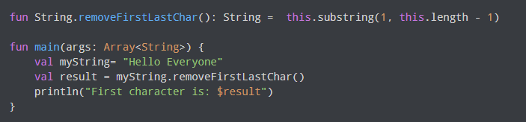

6 Explain higher order functions with example

**A higher-order function is a function that takes functions as parameters, or returns a function.**

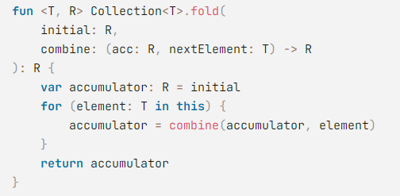

7 What are inline functions

**The use of inline function enhances the performance of higher order function**

8 What are scope functions

**Kotlin scope functions are functions that allow for changing the scope, or the range, of a variable. There are five: apply , run , with , let , and also.**

9 What are companion objects

**Companion objects are singleton objects whose properties and functions are tied to a class but not to the instance of that class**

10 How to mark a class singleton in Kotlin

**By using the object keyword**

11 Difference between late int vs lazy

**Lateinit var can be initialized from anywhere the object is seen from. lazy can only be used for val properties**

12 Difference between val vs var?

**Var can be changed, Val cannot**

13 Crossinline, Noline

**noinline allows to mark a lambda parameter of an inline function**

**Crossinline allows to mark a lambda to stop it from using non-local returns**

14 When to use reified keyword

**In order to use the reified type, you need to use the inline function**